**SMART FARMING – AN IOT ENABLED SMART FARMING APPLICATION**

**TEAMID:PNT2022TMID03166**

**PROJECT REPORT**

1. **INTRODUCTION**

1.1 Overview

This is a Smart Farming application project based on Internet Of Things (IoT), that can measure soil moisture, Humidity and temperature conditions for agriculture using Watson IoT services. IoT is network that connects physical objects or things embedded with electronics, software and sensors through network connectivity that collects and transfers data using cloud for communication. Data is transferred through internet without human to human or human to computer interaction.

In this project we have not used any hardware. Instead of real soil moisture, Humidity and Temperature data obtained from sensors we make use of IBM IoT Simulator which can transmit these parameters as required.

* **Project Requirements** : Node-RED, IBM Cloud, IBM Watson IoT, Node.js, IBMDevice, IBM IoT Simulator, Python 3.8, Open Weather API platform.
* **Project Deliverables** : Application for IoT based Smart Agriculture System

1.2 Purpose

IoT based farming is grooming nowadays because it improves the entire agriculture system by monitoring the field in real-time. With the help of IoT in agriculture not only saves the time but also reduces the extravagant use of resources such as water and electricity.

Sometimes due to over or less supply of water in the agricultural field crops may not grow proper. Using IoT supply of water and growth of plants can be satisfied to a greater extent. The flow of water can be controlled from the application. Thus this approach towards Agriculture will help the farmers to get better yield at low cost and without much usage of Resources .

1. **LITERATURE SURVEY**
   1. **Existing problem**

India is agriculture sector, on either side, is losing ground every day, affecting the ecosystem's output capacity. In order to restore vitality and put agriculture back on a path of higher growth, there is a growing need to resolve the issue. A large-scale agricultural system necessitates a great deal of upkeep, knowledge, and oversight. The IoT is a network of interconnected devices that can transmit and receive data over the internet and carry out tasks without human involvement. Agriculture provides a wealth of data analysis parameters, resulting in increased crop yields. The use of IoT devices in smart farming aids in the modernization of information and communication. For better crop growth moisture, mineral, light and other factors can be assumed. This research looks into a few of these characteristics for data analysis with the goal of assisting users in making better agricultural decisions using IoT. The technique is intended to help farmers increase their agricultural output.

1)Accidental deforestation  
2) Soil erosion  
3) High water usage  
4) Energy wastage  
5) Carbon emissions

6) Time consuming process

7) Poor outcomes of cultivation

8) Defense priority not customized to

Prevent intruding animals

* 1. **References**

**1.Zuraida Muhammad, Muhammad Azri Asyraf Mohd Hafez, Nor Adni MatLeh, Zakiah Mohd Yusoff , Shabinar Abd Hamid [1]** The term "Internet of Things" refers to the connection of objects, equipment, vehicles, and other electronic devices to a network for the purpose of data exchange (IoT). The Internet of Things (IoT) is increasingly being utilised to connect objects and collect data. As a result, the Internet of Things' use in agriculture is crucial

**2.Divya J., Divya M.,Janani V. [2]**Agriculture is essential to India's economy and people's survival. The purpose of this project is to create an embedded-based soil monitoring and irrigation system that will reduce manual field monitoring and provide information via a mobile app. The method is intended to help farmers increase their agricultural output. A pH sensor, a temperature sensor, and a humidity sensor are among the tools used to examine the soil. Based on the findings, farmers may plant the best crop for the land

3**.** **H.G.C.R. Laksiri, H.A.C. Dharmagunawardhana, J.V. Wijayakulasooriya** [3]  Development of an effective loT-based smart irrigation system is also a crucial demand for farmers in the field of agriculture. This research develops a low-cost, weather-based smart watering system. To begin, an effective drip irrigation system must be devised that can automatically regulate water flow to plants based on soil moisture levels. Then, to make this water-saving irrigation system even more efficient, an IoT-based communication feature is added, allowing a remote user to monitor soil moisture conditions and manually adjust water flowH.G.C.R. Laksiri, H.A.C. Dharmagunawardhana, J.V. Wijayakulasooriya [3]  Development of an effective loT-based smart irrigation system is also a crucial demand for farmers in the field of agriculture. This research develops a low-cost, weather-based smart watering system. To begin, an effective drip irrigation system must be devised that can automatically regulate water flow to plants based on soil moisture levels. Then, to make this water-saving irrigation system even more efficient, an IoT-based communication feature is added, allowing a remote user to monitor soil moisture conditions and manually adjust water flow

* 1. **Problem Statement Definition**

Mr. Arvind is a farmer with a background in engineering. Together with his father, he has ventured into agriculture. Since he is just starting out in farming, he needs someone to help him through the first few years. He also wants to incorporate technology into farming to cut down on work and labor, increase productivity, produce more, and get ideas for how to improve the soil and plant the next crop. He is actively looking into a few agricultural products that can help him. Many beginning and experienced farmers face these issues

* Who does the problem affect?
* What are the boundaries of the problem?
* What is the issue?
* When does the issue occur?
* Why is it important that we fix the problem?
* What solution to solve this issue?

1. **IDEATION & PROPOSED SOLUTION**
   1. **Empathy Map Canvas**

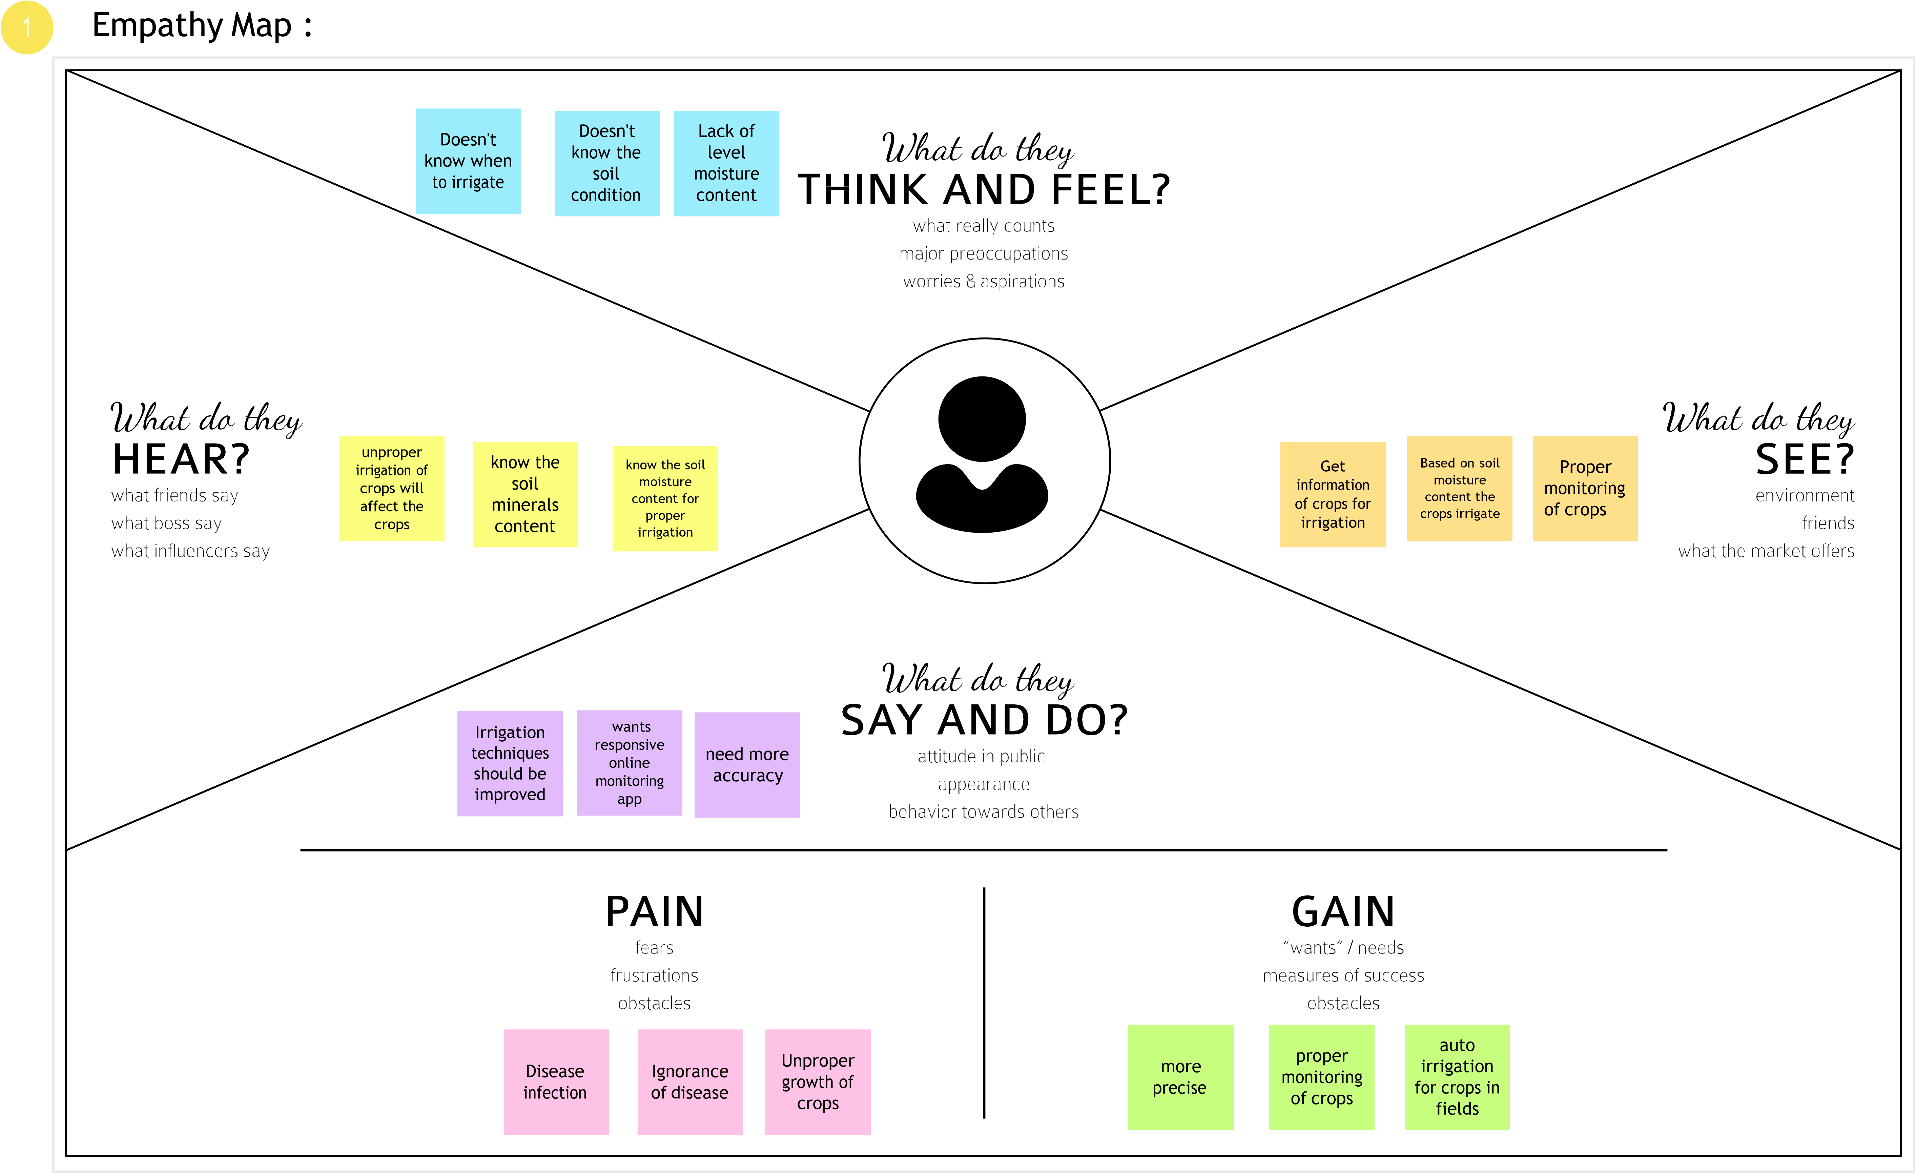

* 1. **Ideation & Brainstorming**

Ideation is the process where you generate ideas and solutions through sessions such as Sketching, Prototyping, Brainstorming, Brainwriting, Worst Possible Idea, and a wealth of other ideation techniques.

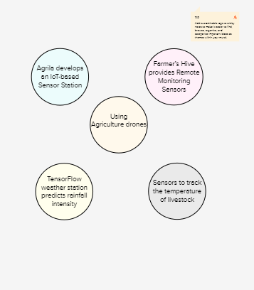

* 1. **Proposed Solution**
  2. Problem Statement

Watering the field is a difficult process, Farmers have to wait in the field until the water covers the whole farm field. Power Supply is also one of the problems. In Village Side, the power supply may vary. The Biggest Challenges Faced by IoT in the Agricultural Sector are Lack of Information, High Adoption, Cost and Security Concerns, etc

Idea / Solution description

As is the case of precision Agriculture Smart Farming Technique Enables Farmers better to monitor the fields and maintain the humidity level accordingly. The Data collected by sensors, In terms of humidity, temperature, moisture, and dew detections help in the weather pattern in Farms. So cultivation is done for suitable crops.

Novelty

It helps the farmer to operate the motor from anywhere.

* 1. **Problem Solution fit**





1. **REQUIREMENT ANALYSIS**

## Functional Requirements:

Following are the functional requirements of the proposed solution.

|  |  |  |
| --- | --- | --- |
| **FR No.** | **Functional Requirement (Epic)** | **Sub Requirement (Story / Sub-Task)** |
| FR-1 | User Registration | EMAIL:  Enter email address PASSWORD:  Enter password |
| FR-2 | User Confirmation | Confirmation via Email. Thanks for your email. |
| FR-3 | Log in to system | Serve authenticated content |
| FR-4 | Manage Modules | Manage System Admins Manage Roles of User Manage User permission |
| FR-5 | Check whether condition | Temperature monitoring status  Humidity monitoring  Status |
| FR-6 | Log out | Exit |

## Non-functional Requirements:

Following are the non-functional requirements of the proposed solution.

|  |  |  |
| --- | --- | --- |
| **FR**  **No.** | **Non-Functional Requirement** | **Description** |
| NFR- 1 | **Usability** | Usability includes easy understanding and learn ability, efficiency in use,remember ability, lack of errors in operation and subjective pleasure. |
| NFR- 2 | **Security** | Sensitive and private data must be protected from their production until the decision-making and storage stages. |
| NFR- 3 | **Reliability** | The shared protection achieves a better trade-off between costs and reliability.  The model uses dedicated and shared protection schemes to avoid farm service outages. |

|  |  |  |
| --- | --- | --- |
| NFR-4 | **Performance** | The idea of implementing integrated sensors with sensing soil and environmental parametersin farming will be more efficient. |
| NFR-5 | **Availability** | Automatic adjustment of farming equipment made possible by linking information like crops/weather and equipment to auto-adjust temperature,  humidity, etc. |
| NFR-6 | **Scalability** | Scalability is a major concern for IoT platforms. It has shown that different architectural choices of IoT platforms affect system scalability,real time decision- making is feasible in an environment composed of dozens of thousand. |

1. **PROJECT DESIGN**
   1. **Data Flow Diagrams**

A Data Flow Diagram (DFD) is a traditional visual representation of the information flows within a system. A neat and clear DFD can depict the right amount of the system requirement graphically. It shows how data enters and leaves the system, what changes the information, and where data is stored.

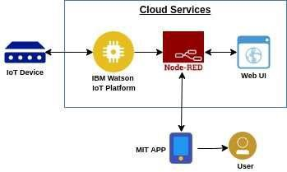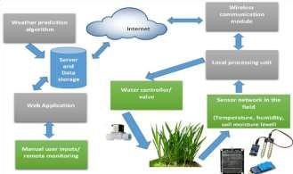

* The different soil parameters temperature, soil moistures and then humidity are sensed using different sensors and obtained value is stored in the IBM cloud.
* Arduino UNO is used as a processing Unit that process the data obtained from the sensors and whether data from the weather API.
* NODE-RED is used as a programming tool to write the hardware, software, and APIs. The MQTT protocol is followed for the communication.
* All the collected data are provided to the user through a mobile application that was developed using the MIT app inventor.
* The user could plan through an app, weather to water the crop or not depending upon the sensor values. By using the app, they can remotely operate to the motor switch.
  1. **Solution & Technical Architecture:**

**Solution Architecture:**

Solution architecture is a complex process – with many sub-processes – that bridges the gap between business problems and technology solutions. Its goals are to:

* Find the best tech solution to solve existing business problems.
* Describe the structure, characteristics, behavior, and other aspects of the software to project stakeholders.
* Define features, development phases, and solution requirements.
* Provide specifications according to which the solution is defined, managed, and delivered.

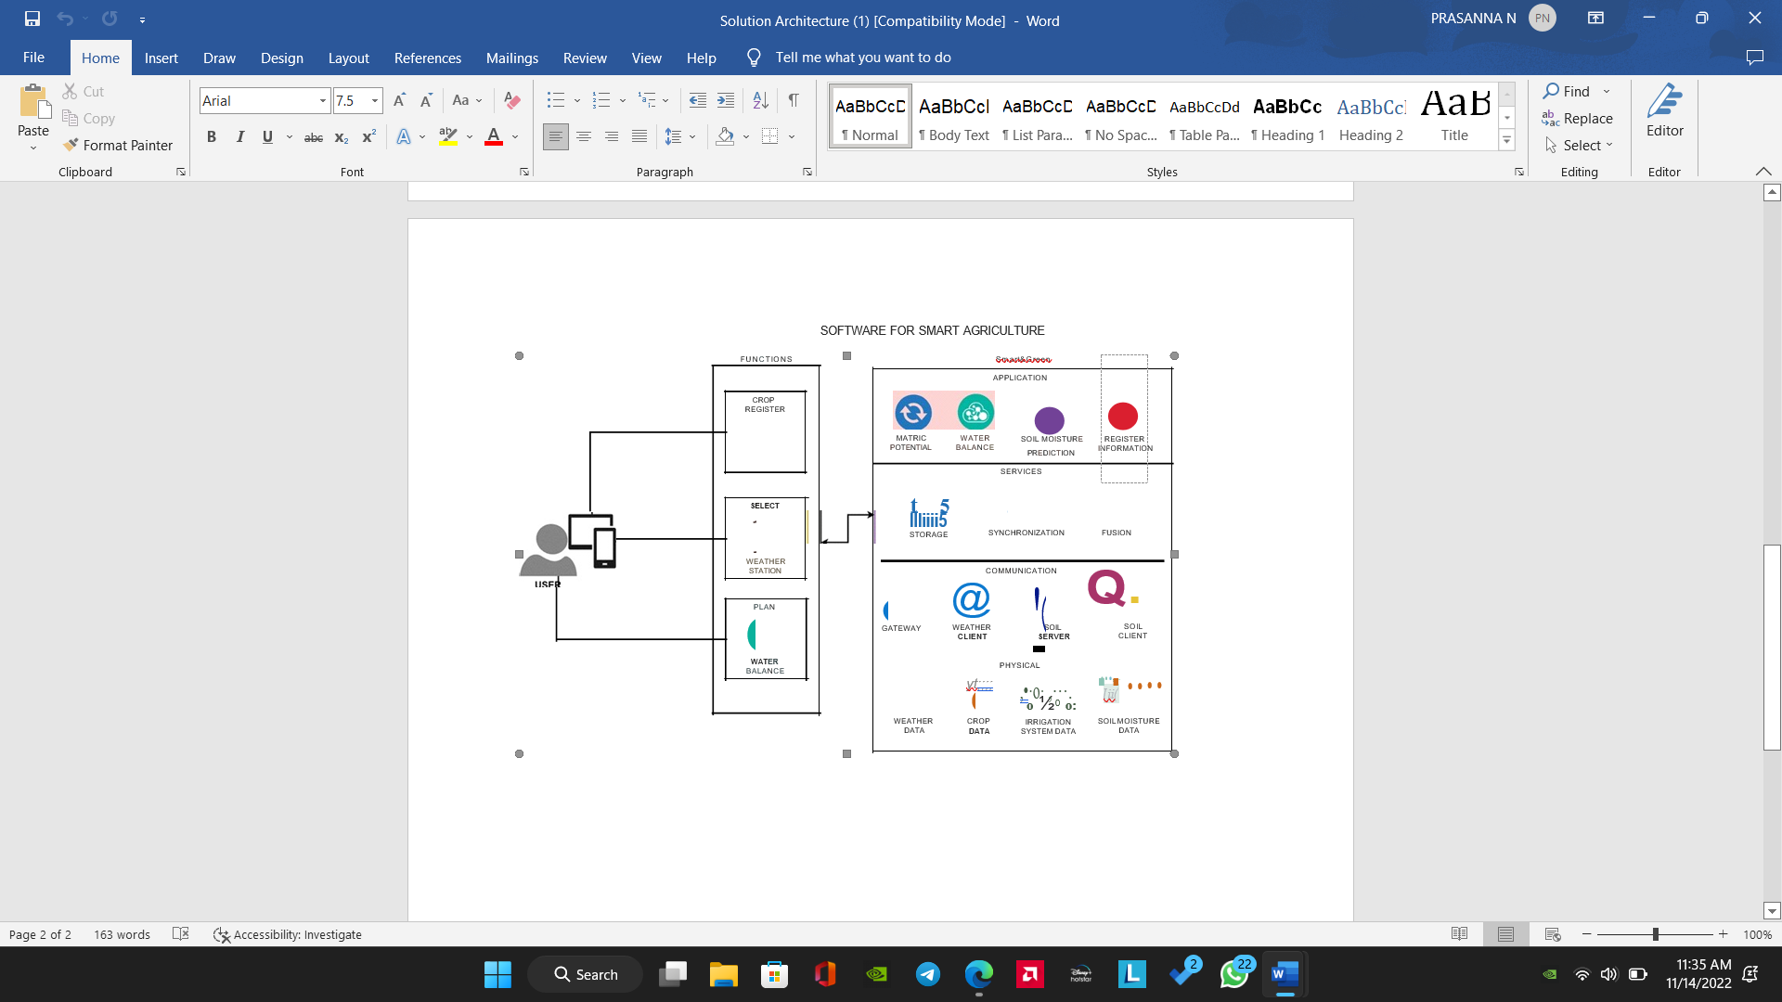

* 1. **User Stories**

|  |  |  |  |  |  |  |
| --- | --- | --- | --- | --- | --- | --- |
| **User Type** | **Functional Requirement** | **User Story Number** | **User Story/Task** | **Acceptance criteria** | **Priority** | **Release** |
| Customer (Mobile user) | Registration | USN-1 | As a user, I can register for the application by entering my  email, password and confirming my password. | I can access my account/ dashboard | High | Sprint-1 |
|  | Permission | USN-2 | As a user, I will receive confirmation email once I have registered for the application. | I can receive confirmation email & click  confirm. | High | Sprint-1 |
| Customer (Web user) | Login | USN-3 | As a user, I can log into the application by entering email & password. | I can register & access  the dashboard with Login | High | Sprint-2 |
|  | Check credentials | USN-4 | As a user, I can register for the application through mobile application | Temperature and  Humidity details | Medium | Sprint-1 |
|  | Dashboard | USN-5 | As a user can view the dashboard and this dashboard include the check roles of access and then move to the manage modules. | I can view the dashboard in this smart farming application system. | Medium | Sprint-1 |
| Customer care Executive | MIT app | USN-6 | To make the user to interact with the software. | Database to store in cloud services. | High | Sprint-1 |
| Administrator | IOT devices | USN-7 | As a user once view the manage modules this describes the manage system admins and Manage Roles of user and etc.., |  | Medium | Sprint-1 |
|  | Log out | USN-8 | Exit | Sign out | High | Sprint-1 |

**5.PROJECT PLANNING & SCHEDULING**

5.1 Sprint Planning & Estimation

**Product Backlog, Sprint Schedule, and Estimation**

|  |  |  |  |  |  |  |
| --- | --- | --- | --- | --- | --- | --- |
| **Sprint** | **Functional Requirement (Epic)** | **User Story Number** | **User Story /Task** | **Story Points** | **Priority** | **Team Member** |
| **Sprint-1** | Registration (Farmer Mobile User) | UNS-1 | As a user, I can register for the application by entering my email, password, and confirming my  password. | 2 | High | PRATEEK RAM RA  (Leader) |
| **Sprint-1** | Login | UNS-2 | As a user, I will receive confirmation email once I have registered  for the application | 1 | High | PRASANNA N  (Member 1) |

|  |  |  |  |  |  |  |
| --- | --- | --- | --- | --- | --- | --- |
| **Sprint-2** | User Interface | UNS-3 | As a user, I can register for the application through Facebook | 3 | Low | PREMKUMAR  (Member 2) |
| **Sprint-1** | Data Visualization | UNS-4 | As a user, I can register  for the application through GMAIL | 2 | Medium | PRAVIN KUMAR P  (Member 3) |
| **Sprint-3** | Registration (Farmer -Web User) | USN - 1 | As a user, I can log into the application by entering email and  password | 3 | High | PRATEEK RAM RA  (Leader) |
| **Sprint - 2** | Login | USN - 2 | As a registered user, I need to easily login log into my registered account via the web page in minimum time | 3 | High | PRASANNA N  (Member 1) |
| **Sprint - 4** | Web UI | USN - 3 | As a user, I need to have a friendly user interface to easily view and access the resources | 3 | Medium | PREM KUMAR B  (Member 2) |
| **Sprint - 1** | Registration (Chemical Manufacturer - Web user) | USN - 1 | As a new user, I want to first register using my organization email and create a password for  the account. | 2 | High | PRAVIN KUMAR P  (Member 3) |

|  |  |  |  |  |  |  |
| --- | --- | --- | --- | --- | --- | --- |
| **Sprint - 4** | Login | USN - 2 | As a registered user, I need to easily log in using the registered account via the web  page. | 3 | High | PRATEEK RAM RA  (Leader) |
| **Sprint - 3** | Web UI | USN - 3 | As a user, I need to have a user friendly interface to easily view and access the resources. | 3 | Medium | PRASANNA N  (Member 1) |
| **Sprint - 1** | Registration (Chemical Manufacturer -  Mobile User) | USN - 1 | As a user, I want to first register using my email and create a password  for the account. | 1 | High | PREM KUMAR B  (Member 2) |
| **Sprint - 1** | Login | USN - 2 | As a registered user, I  need to easily log in to the application. | 2 | Low | PRAVIN KUMAR P  (Member 3) |

**Project Tracker, Velocity & Burndown Chart:**

|  |  |  |  |  |  |  |
| --- | --- | --- | --- | --- | --- | --- |
| **Sprint** | **Total Story**  **Points** | **Durati on** | **Sprint Start**  **Date** | **Sprint End Date**  **(Planned)** | **Story Points Completed (ason Planned End Date)** | **Sprint Release Date (Actual)** |
| Sprint-1 | 12 | 6 Days | 24 Oct 2022 | 29 Oct 2022 | 20 | 29 Oct 2022 |
| Sprint-2 | 6 | 6 Days | 31 Oct 2022 | 05 Nov 2022 | 20 | 30 OCT 2022 |
| Sprint-3 | 6 | 6 Days | 07 Nov 2022 | 12 Nov 2022 | 20 | 6 NOV 2022 |
| Sprint-4 | 6 | 6 Days | 14 Nov 2022 | 19 Nov 2022 | 20 | 7 NOV 2022 |

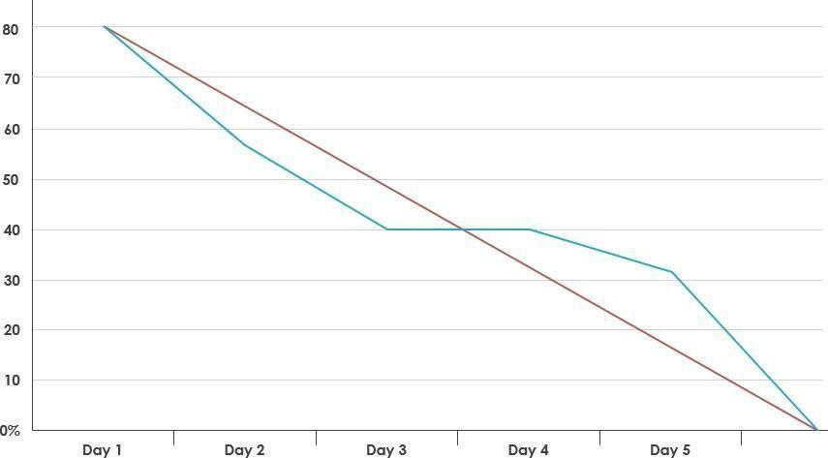**Burndown Chart**

Experimental Investigation:

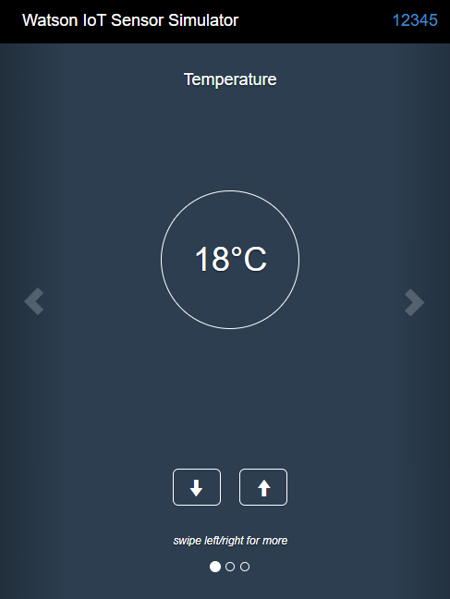

**Fig(a) Watson Iot Simulator**

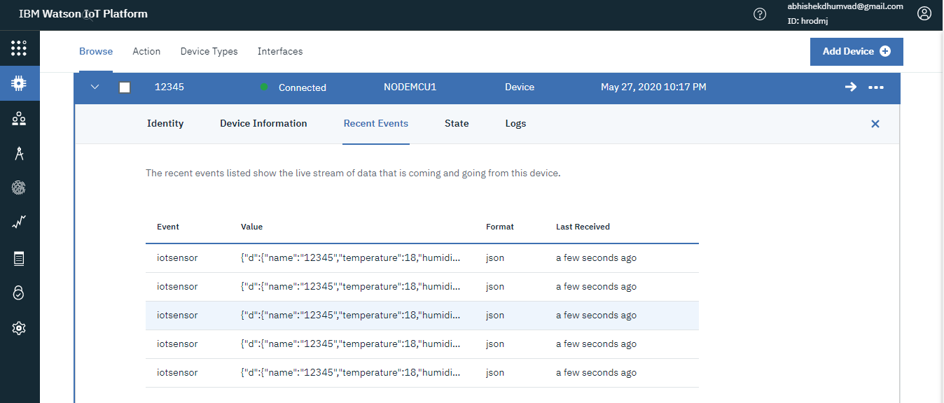

**Fig(b)Receiving data from Iot simulator to the**

**IBM watson IOT platform through IBM cloud**

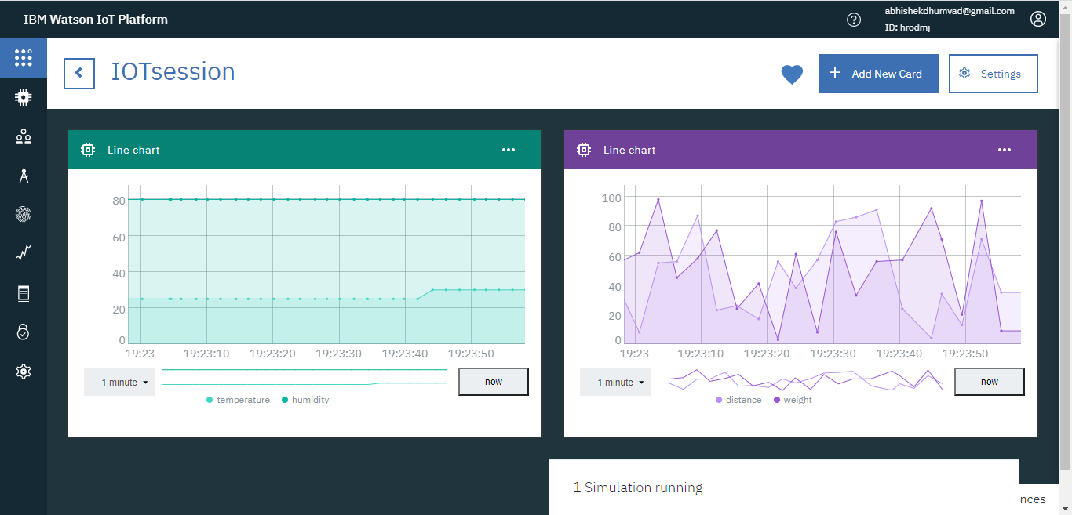

**Fig(c)Representation of Received data through graphs**

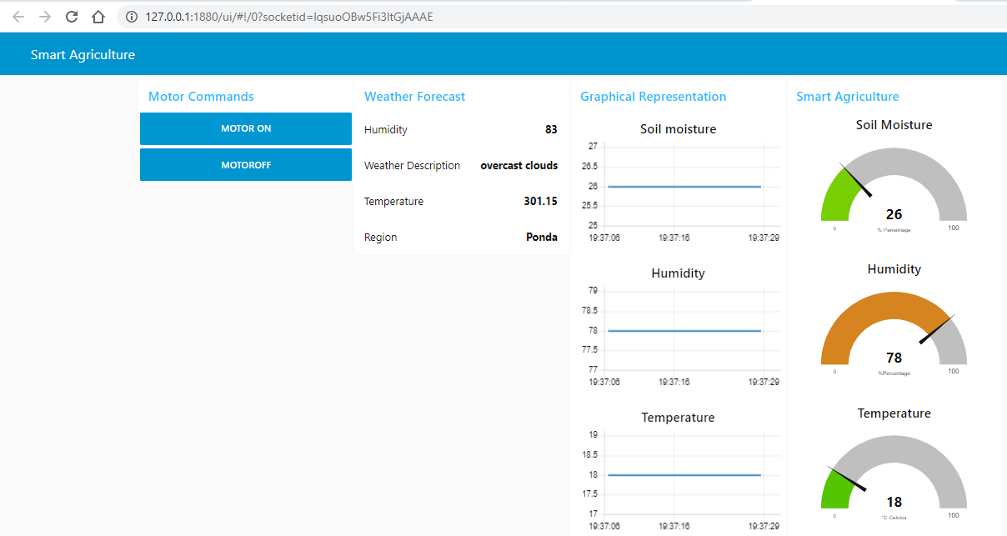 **fig(d) Web Application for Smart Agriculture System**

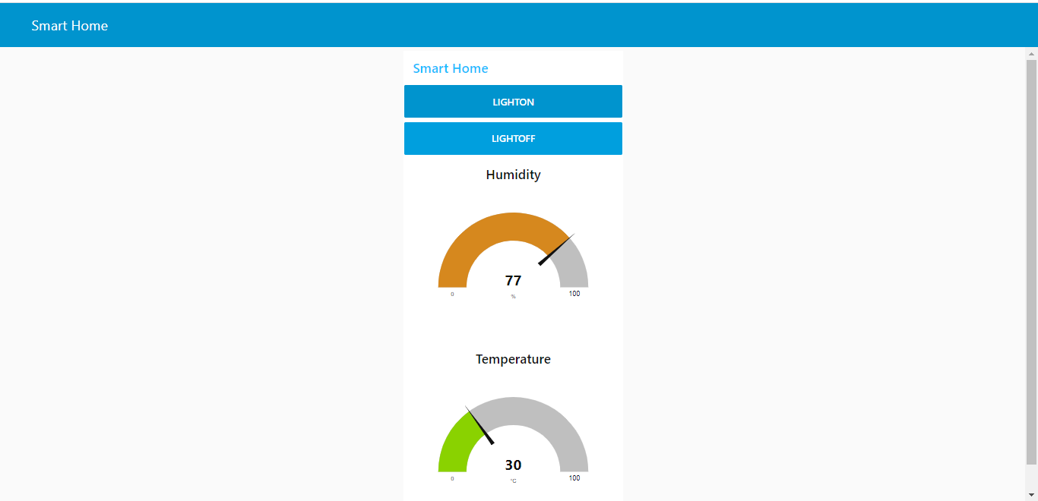

**Fig(e) An illustration of Web App - Smart Home**

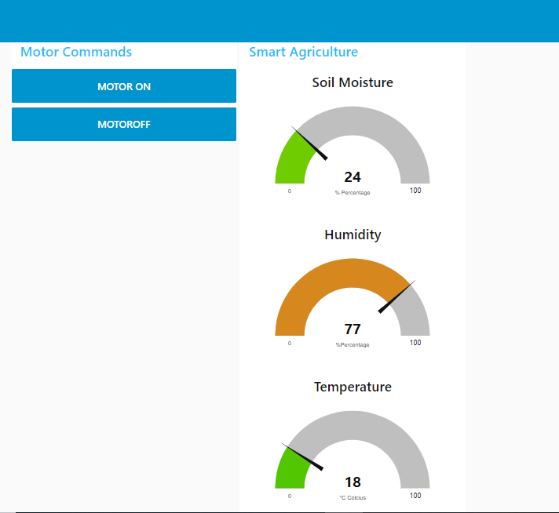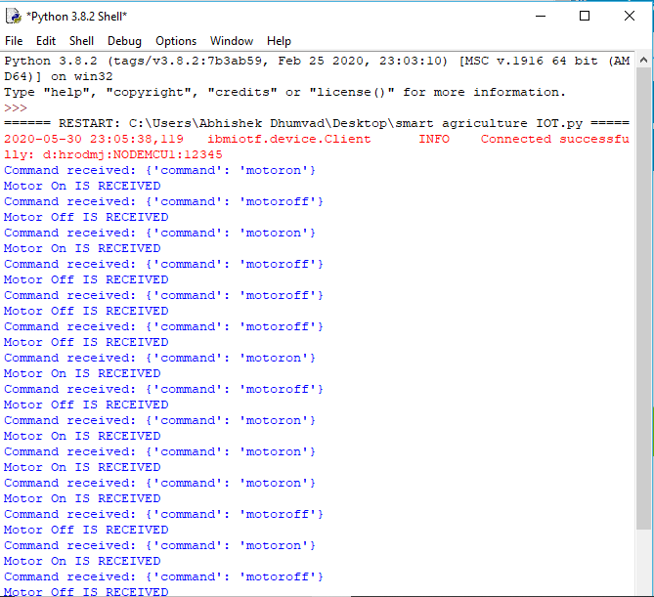

**fig(f) Device Control Action**

In this project we send the weather data through IoT Simulator shown in fig(a) instead of real soil and temperature conditions. Simulator passes the data through IBM Cloud to the web application. The data is displayed on the dashboard show in fig(b1 & b2). Web Application is build using Node-RED. We have created 2 tabs:

1. IoT Smart Agriculture.
2. Graphical Representation.

Web Application is also used to control the devices further like motor, pumps, lights, or any other devices in the agricultural field. In this project the output is passed using python code and the control action is displayed in python code console window in fig(c).

5) Flowchart:

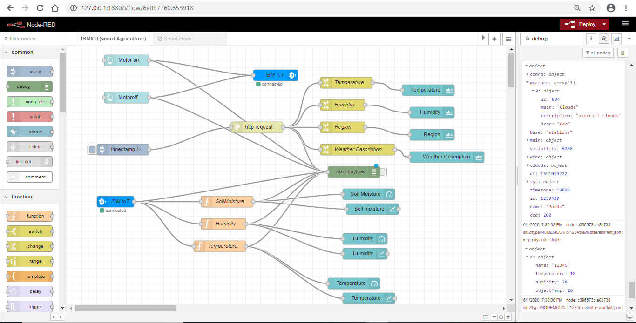

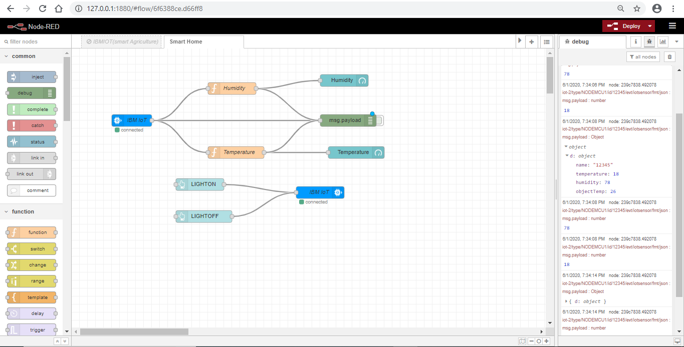

**Following are the nodes used in the project in the Web Application:**

1. IBM IoT : IN and OUT Nodes.
2. function Nodes.
3. Gauge Nodes.
4. Chart Nodes.
5. Debug Node.
6. Button Nodes.

**Following are the nodes used for the weather condition from open weather map:**

1. Timestamp Node.
2. http request Node
3. Function Nodes.
4. Text Nodes.

Debug Node.

1. **CODING & SOLUTIONING (Explain the features added in the project along with code)**
   1. Feature 1
   2. Feature 2
   3. Database Schema (if Applicable)
2. **TESTING** 
   1. Test Cases
   2. User Acceptance Testing
3. **RESULTS**
   1. Performance Metrics
4. **ADVANTAGES & DISADVANTAGES**
5. **CONCLUSION**
6. **FUTURE SCOPE**
7. **APPENDIX**

Source Code

**A.GitHub&ProjectDemoLink**; https://drive.google.com/file/d/17DOII5f56PmMnWVM4SnSA227E8NtT94I/view?usp=drivesdk

**B.Source Code**

import time

import sys

import ibmiotf.application # to install pip install ibmiotf

import ibmiotf.device

#Provide your IBM Watson Device Credentials

organization = "hrodmj" #replace the ORG ID

deviceType = "NODEMCU1"#replace the Device type wi

deviceId = "12345"#replace Device ID

authMethod = "token"

authToken = "abhi1234" #Replace the authtoken

def myCommandCallback(cmd): # function for Callback

print("Command received: %s" % cmd.data)

if cmd.data['command']=='motoron':

print("Motor On IS RECEIVED")

elif cmd.data['command']=='motoroff':

print("Motor Off IS RECEIVED")

if cmd.command == "setInterval":

if 'interval' not in cmd.data:

print("Error - command is missing required information: 'interval'")

else:

interval = cmd.data['interval']

elif cmd.command == "print":

if 'message' not in cmd.data:

print("Error - command is missing required information: 'message'")

else:

output=cmd.data['message']

print(output)

try:

deviceOptions = {"org": organization, "type": deviceType, "id": deviceId, "auth-method": authMethod, "auth-token": authToken}

deviceCli = ibmiotf.device.Client(deviceOptions)

#..............................................

except Exception as e:

print("Caught exception connecting device: %s" % str(e))

sys.exit()

# Connect and send a datapoint "hello" with value "world" into the cloud as an event of type "greeting" 10 times

deviceCli.connect()

while True:

deviceCli.commandCallback = myCommandCallback

# Disconnect the device and application from the cloud

deviceCli.disconnect()